Find the x- and y- intercepts of the line. Use the intercepts to graph the line.
3x + 2y = 6  x-intercept: ( , )  y-intercept ( , )  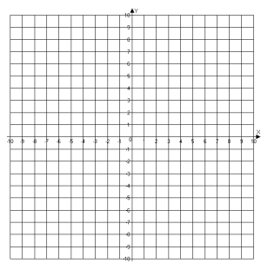 | 3x - 2y = 12  x-intercept: ( , )  y-intercept ( , )
2x + 4y = -8  x-intercept: ( , )  y-intercept ( , ) | -3x + 12y = 24  x-intercept: ( , )  y-intercept ( , )
3x = 3y + 6  x-intercept: ( , )  y-intercept ( , ) | -5x = 10y + 30  x-intercept: ( , )  y-intercept ( , )
4y = 7x + 28  x-intercept: ( , )  y-intercept ( , ) | 4x - 1y = - 4  x-intercept: ( , )  y-intercept ( , )

