Name: _____________________________________________________ February 9, 2015

Shape |  | Area or Volume | Example
Rectangle

Rectangular
Prism

Rectangular  Pyramid | 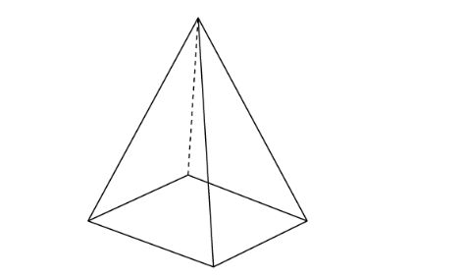

Shape |  | Area or Volume | Example
Triangle

Triangular  Prism | 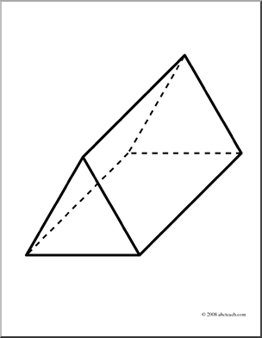
Triangular  Pyramid | 