Name_____________________________________________ November 11, 2014
Today’s Objective:

Vocabulary:  Finding intercepts with a graph:  Finding intercepts with an equation:  Using Intercepts to graph linear equations: | x-intercept  y-intercept  standard form of a linear equation  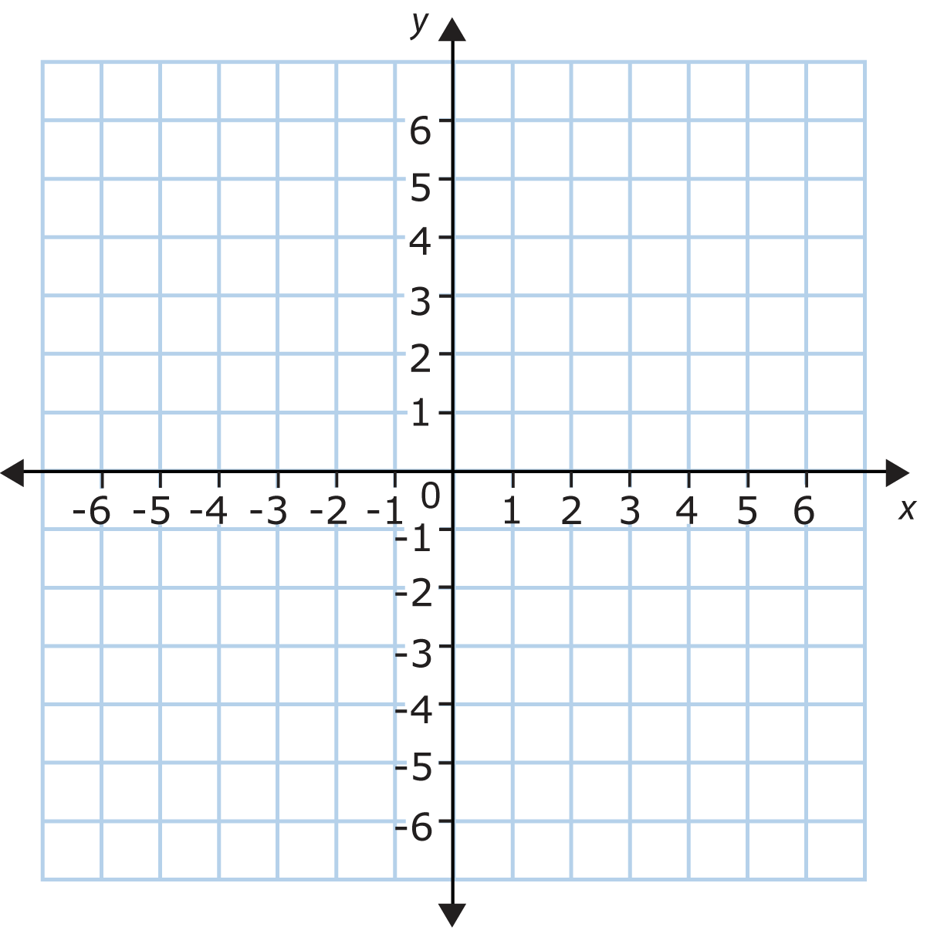  To find the x-intercept, ______________________________________________________.  To find the y-intercept, ______________________________________________________.  Example 1: Find the x- and y-intercept of the equation 5x – 2y = 10.  x-intercept ( , ) y-intercept ( , )  5x – 2y = 10  x-intercept ( , ) y-intercept ( , )

