SYSTEMS OF EQUATIONS
All solutions to a linear equation are on its graph.

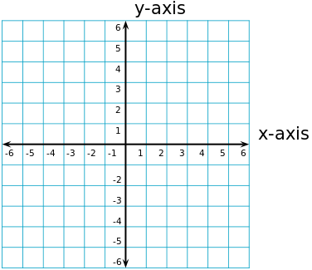

y = x + 2

y = x + 2
y = -x + 2

y = x + 3
y = x

y = x + 2
2y - 2x = 4

