Solving Systems of Equations using a Graphing Calculator

1.  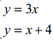  Solution: _________ | 2.  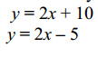  Solution: __________ | 3.  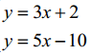  Solution: __________ | 4.  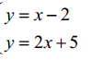  Solution: __________
5.  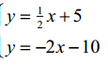  Solution: _________ | 6.  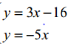  Solution: _________ | 7.  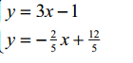  Solution: _________ | 8.  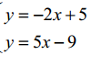  Solution: _________
9.  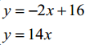  Solution: _________ | 10.  y = 3x + 1  y = 3x -2  Solution: _________ | 11.  y = ½ x – 1  y = $\frac{3}{6}$ x - 1  Solution: _________ | 12.  y = 2x + 6  y = 3x + 4  Solution: _________
13.  y = 2x  y = 4x -8  Solution: _________ | 14.  y = 5x - 1  y = 6x - 2  Solution: _________ | 15.  Y = 7x - 3  Y = 9x - 7  Solution: _________ | 16.  Y = ½ x + 1  Y = x - 1  Solution: _________

