Name _________________________________ November 13, 2014

Today’s Objective:

Vocabulary:  Ways to express slope:  Different types of slope:  Finding slope from a graph:  Finding slope from a set of ordered pairs: | Slope:  - positive 2) negative  SLOPE MAN  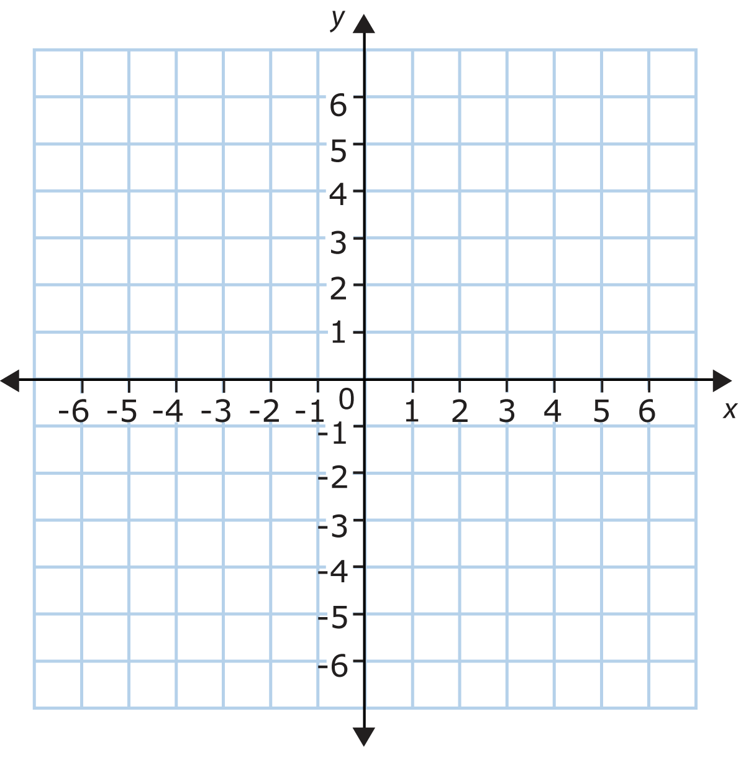  ( -2, -2 ) ( 4, 1 )

