Name: ________________________________________ November 12, 2014

Today’s objective:

What is rate of change?  Example 1: | A rate of change is a ratio that compares the amount of change in a dependent variable to the amount of change in an independent variable.  Rate of change = ___________________________________  The table shows the average temperature (°F) for five months in a certain city. Find the rate of change for each time period.  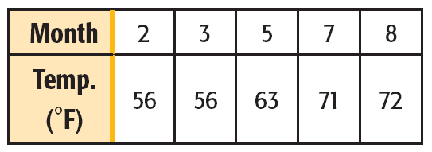  Dependent variable:  Independent variable:  Rate of change: _______________________________  Month 2 to 3:  Month 3 to 5:  Month 5 to 7:  Month 7 to 8:

FIND RATE OF CHANGE
- The table shows the balance of a bank account on different days of the month. Find the rate of change during each time interval.

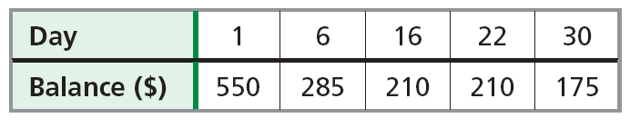

Dependent Variable: _________________ Independent Variable: __________________

Day 1 to 6: Day 16 to 22:

Day 6 to 16: Day 22 to 30:

- Find the rate of change:  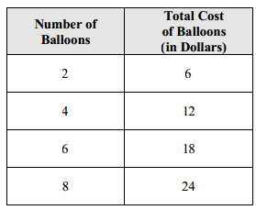  DV: ______________ IV: _______________  2 to 4 balloons: 6 to 8 balloons:  4 to 6 balloons: | - Find the rate of change:  Year Population  1 12,000  3 14,000  4 25,000  7 43,000  DV: ______________ IV:_______________  1 to 3 years: 4 to 7 years:  3 to 4 years:
- Find the rate of change:  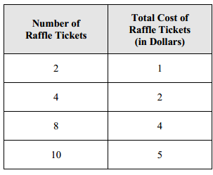  DV: ______________ IV: _______________  2 to 4 tickets: 8 to 10 tickets:  4 to 8 tickets: | - Find the rate of change:  Hours: Miles Driven  1 70  5 310  10 660  12 790  DV: ______________ IV: _______________  1 to 5 hours: 10 to 12 hours:  5 to 10 hours:
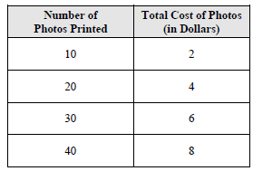  DV: ______________ IV: _______________  10 to 20 photos: 30 to 40 photos:  20 to 30 photos: | 7.  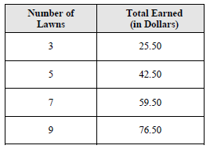  DV: ______________ IV: _______________  3 to 5 lawns: 7 to 9 lawns:  5 to 7 lawns:
8.  Number of Cookies Total Cost $  1 1  5 4  12 7.50  36 12.30  DV: ______________ IV: _______________  1 to 5 cookies: 12 to 36 cookies:  5 to 12 cookies: | 9.  Day Total Calories Consumed  1 2,000  5 8,000  10 15,500  12 18,500  DV: ______________ IV: _______________  1 to 5 days: 10 to 12 days:  5 to 10 days:

