QUADRATIC FUNCTIONS

Standard Form: | Ax² + Bx + C = y  Ex: 2x² + 3x + 4 = y or -3x² - 5x - 1 = y  A= B= C= A= B= C=  A. A > 0 Vertex: maximum or minimum Vertex: ( , ) Minimum = _________  B. A < 0 Vertex: maximum or minimum Vertex: ( , ) Maximum = _________  A. Domain: _________________ Range: ___________________  B. Domain: _________________ Range: ___________________

A > 0 or A < 0  Vertex: minimum or maximum  Vertex: ( , )  Minimum/Maximum = _________  Domain: _____________  Range: _______________ | 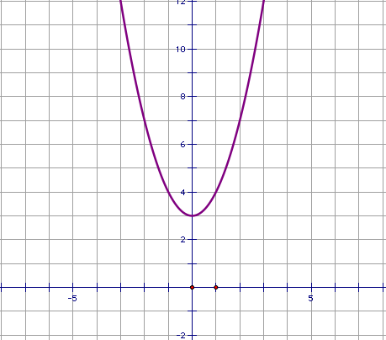
A > 0 or A < 0  Vertex: minimum or maximum  Vertex: ( , )  Minimum/Maximum = _________  Domain: _____________  Range: _______________ | 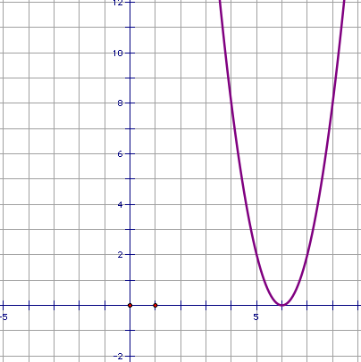
A > 0 or A < 0  Vertex: minimum or maximum  Vertex: ( , )  Minimum/Maximum = _________  Domain: _____________  Range: _______________ | 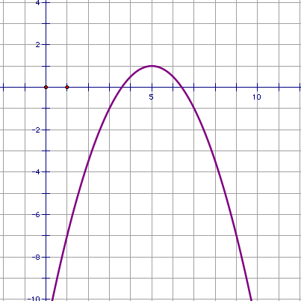
A > 0 or A < 0
Vertex: minimum or maximum
Vertex: ( , )
Minimum/Maximum = _________
Domain: _____________
Range: _______________

A > 0 or A < 0  Vertex: minimum or maximum  Vertex: ( , )  Minimum/Maximum = _________  Domain: _____________  Range: _______________ | 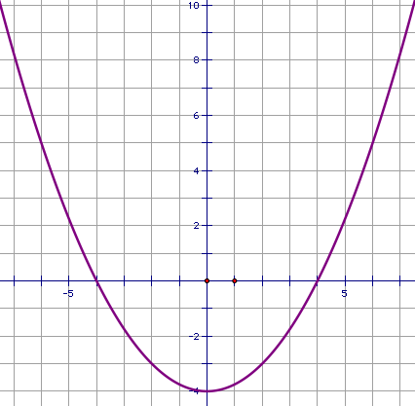
A > 0 or A < 0  Vertex: minimum or maximum  Vertex: ( , )  Minimum/Maximum = _________  Domain: _____________  Range: _______________ | 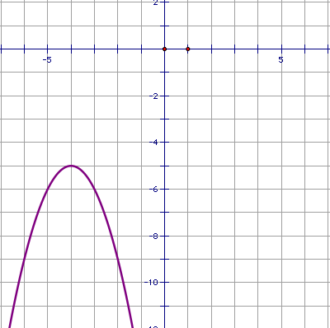
A > 0 or A < 0  Vertex: minimum or maximum  Vertex: ( , )  Minimum/Maximum = _________  Domain: _____________  Range: _______________ | 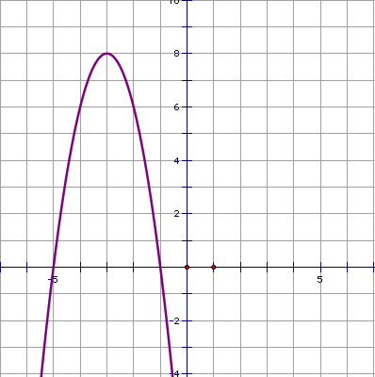
A > 0 or A < 0
Vertex: minimum or maximum
Vertex: ( , )
Minimum/Maximum = _________
Domain: _____________
Range: _______________

A > 0 or A < 0  Vertex: minimum or maximum  Vertex: ( , )  Minimum/Maximum = _________  Domain: _____________  Range: _______________ | 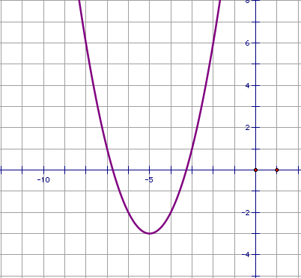
A > 0 or A < 0  Vertex: minimum or maximum  Vertex: ( , )  Minimum/Maximum = _________  Domain: _____________  Range: _______________ | 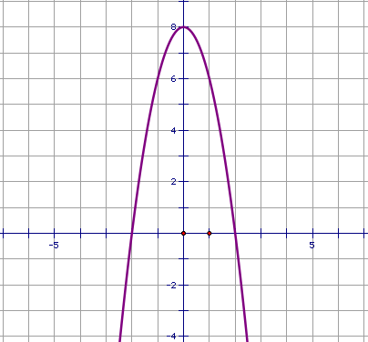
A > 0 or A < 0  Vertex: minimum or maximum  Vertex: ( , )  Minimum/Maximum = _________  Domain: _____________  Range: _______________ | 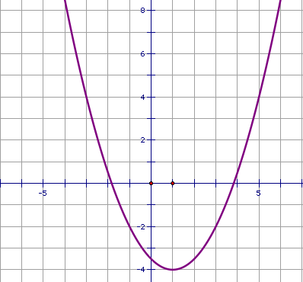
A > 0 or A < 0
Vertex: minimum or maximum
Vertex: ( , )
Minimum/Maximum = _________
Domain: _____________
Range: _______________

