Name: ___________________________ 12/5/2014

Graph the equation in point slope form below.
y – 2 = $\frac{1}{2}$ (x – 1)  point ( , )  m = ______________ | 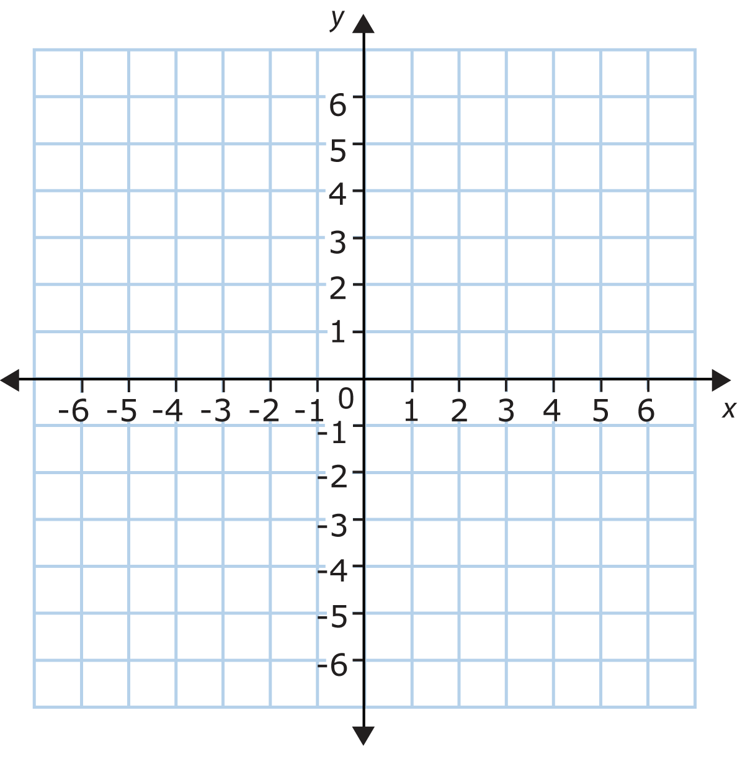
y + 2 = $\frac{2}{5}$ (x + 1)

point ( , )

m = ______________

y - 2 = $\frac{-1}{3}$ (x + 1)

point ( , )

m = ______________

