Name: ___________________________ 12/4/2014
Find the equation of the line with the given slope that passes through the given point. Write the equation of the line in point-slope form.
y – y₁ = m (x - x₁)
1. m = 2 and (-1, -3) | 2. m = -7 and (1, -1)  ` | 3. m = -2 and (-5, -2) | 4. m = 6 and (-2, 5)

Find the equation of each line graphed below. Write in point slope form.
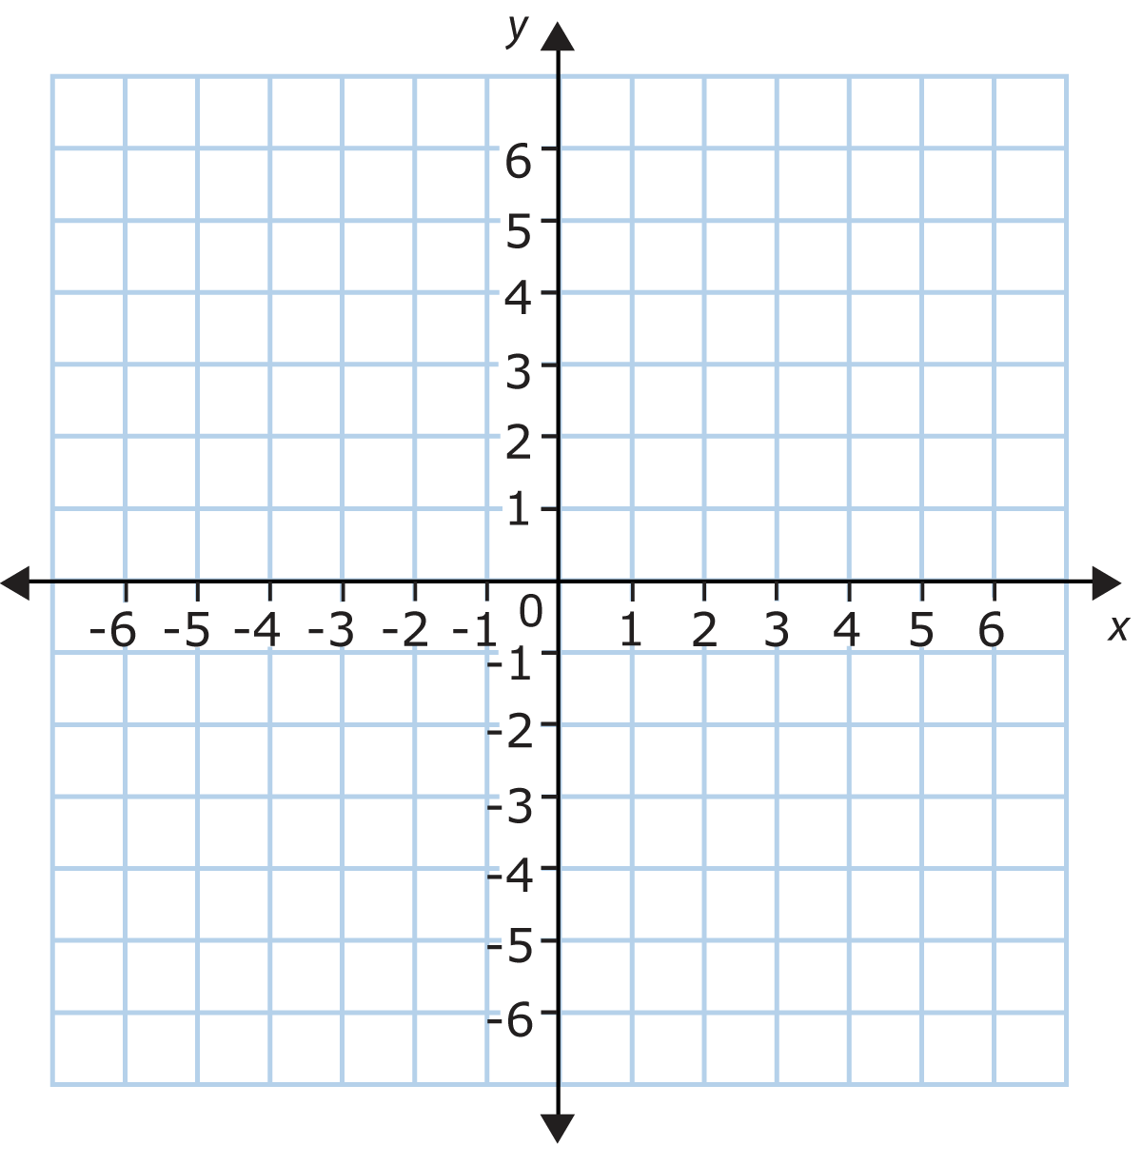 | point ( , )  m = ______________  y – y₁ = m (x - x₁)  ______________________________________________
point ( , )

m = ______________

y – y₁ = m (x - x₁)

______________________________________________
point ( , )

m = ______________

y – y₁ = m (x - x₁)

______________________________________________

Graph the equation in point slope form below.
y – 2 = $\frac{1}{2}$ (x – 1)

point ( , )

m = ______________

y + 2 = $\frac{2}{5}$ (x + 1)

point ( , )

m = ______________

y - 2 = $\frac{-1}{3}$ (x + 1)

point ( , )

m = ______________

