Name____________________________________________________ December 3, 2014

DETERMINING THE COMPLEMENT OF AN EVENT
Complement-

Example: Rolling a number ≥ 4

Complement of rolling a number ≥ 4

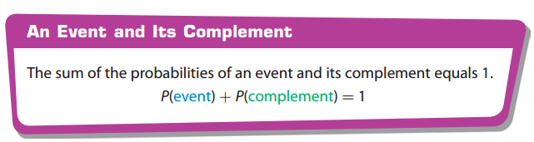

Determining the complement of an event

Example: There are two red jacks in a deck of 52 cards. What is the probability of NOT picking a red card?

