1)Write an equation in point-slope form for the perpendicular bisector of the segment with endpoints C(6, –5) and D(10, 1).

2) Write an equation in point-slope form for the perpendicular bisector of the segment with endpoints P(5, 2) and Q(1, –4).

3) Find the circumcenter of ∆HJK with vertices H(0, 0), J(10, 0), and K(0, 6).

4) Find the circumcenter of ∆GOH with vertices G(0, –9), O(0, 0), and H(8, 0) .

5) A city plans to build a firefighters’ monument in the park between three streets. Draw a sketch to show where the city should place the monument so that it is the same distance from all three streets. Justify your sketch.

6) A sculptor is shaping a triangular piece of iron that will balance on the point of a cone. At what coordinates will the triangular region balance?

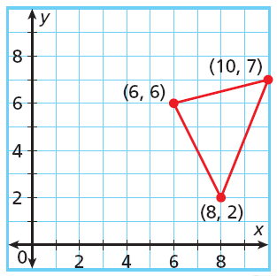
7) Find the orthocenter of ∆XYZ with vertices X(3, –2), Y(3, 6), and Z(7,1)

8) ∆MNP with vertices M (–4, –2), N (6, –2) , and P (–2, 10). Find the coordinates of the centroid and the orthocenter.

