October 14, 2014
Introduction to Functions
- coordinate plane  - axes  - origin  - x-axis  - y-axis | 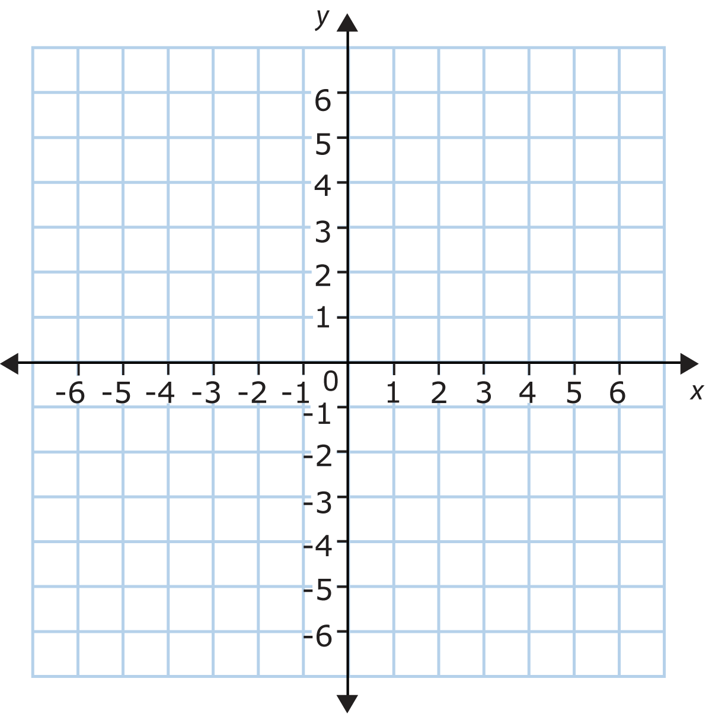

- ordered pair

- x-coordinate

- y-coordinate

- graphing ordered pairs

- quadrant

- input  - output | Input (x)  rule  Output (y)
input (x)  y = 3x  Output (y)  ( 0, ) ( 2, )  ( 1, ) ( 3, ) | Input (x)  y = 2x + 3  Output (y)  ( 0, ) ( 2, )  ( 1, ) ( 3, )
y = x - 1 | y = $\frac{x}{2}$ - 1  x y

