INTRODUCING ONE STEP EQUATIONS (ADDING AND SUBTACTING)
Today’s objective:

Operation:

Inverse Operation:

Addition reverses _____________________. | Subtraction reverses ___________________.

Examples of inverse operation:

Expression vs. Equation

GOLDEN RULE OF EQUATIONS:

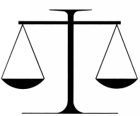

INTRODUCING ONE STEP EQUATIONS… CONT’D
Today’s objective:

GOLDEN RULE OF EQUATIONS:

Variable:

Equations with variables:

Solution:

Isolating the variable

What does the word isolate mean?

Examples:

X + 2 = 11 x – 3 = 1

