INTRODUCING ONE STEP EQUATIONS
Today’s objective:

Operation:

Inverse Operation:

Addition reverses  _____________________. | Subtraction reverses  ___________________.

Multiplication reverses  _____________________. | Division reverses  __________________.

Examples of inverse operation:

Expression vs. Equation

GOLDEN RULE OF EQUATIONS:

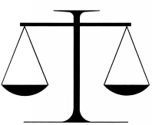

Variable:

Equations with variables:

Solution:

Isolating the variable

Examples:

X + 2 = 11 x – 3 = 1

3x = 6 y/2 = 7

