Name: ______________________________ February 11, 2015

Volume of a Triangular Pyramid
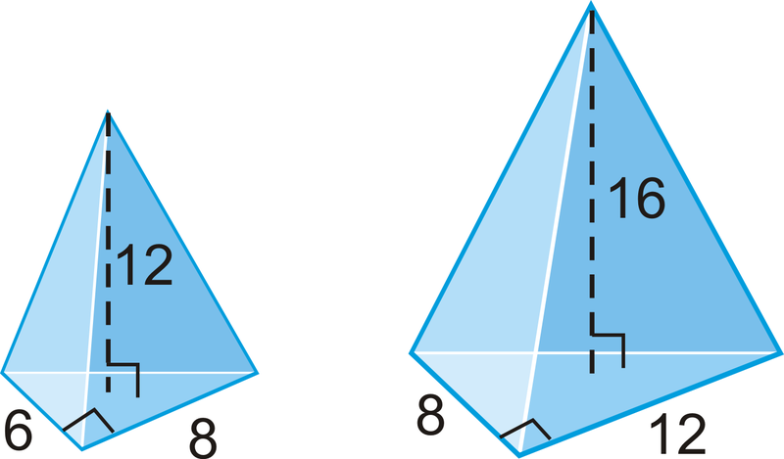

Area of the base triangle: | Area of the base triangle:
Height of the pyramid: | Height of the pyramid:
Volume of the triangular pyramid:  V = $\frac{Area of the base x height}{3}$ | Volume of the triangular pyramid:  V = $\frac{Area of the base x height}{3}$
Volume = | Volume =

