Name: ______________________________ February 11, 2015

Volume of a Triangular Pyramid
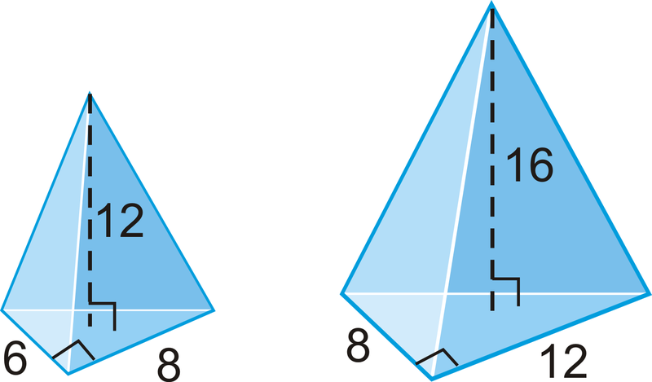

Area of the base triangle: | Area of the base triangle:
Height of the pyramid: | Height of the pyramid:
V = $\frac{Area of the base x height}{3}$ | V = $\frac{Area of the base x height}{3}$
Volume of the triangular pyramid: | Volume of the triangular pyramid:

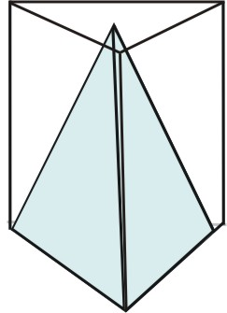

Today, we built a model of a triangular pyramid. A pyramid is a shape that has triangles on each side and comes to a point on top.
Can anyone remember what this shape is called?
The volume of a triangular pyramid is related to the volume of a triangular prism.
VIDEO CLIP
Which is bigger a triangular pyramid or a triangular prism?
How many pyramids fit into a prism? 3
Notice the prism and the pyramid have the same base and the same height.

So we could say that a prism is 3 times larger than a pyramid. We could also say that a pyramid 3 times smaller. So to find the volume of a triangular pyramid, we’ll determine the area of the base multiply that by the height and then divide by 3.

