GRAPHING RELATIONS AND FUNCTIONS
A relationship between variables is often shown as a continuous graph. This relationship can be increasing, decreasing, or constant. When reading a graph, we always read from left to right.
Increasing  The two segments are increasing at different rates.  What words could describe the rate of increase of the first segment?  _______________________________________  What words could describe the rate of increase of the second segment?  ________________________________________ | Decreasing  The two segments are increasing at different rates.  What words could describe the rate of decrease of the first segment?  _______________________________________  What words could describe the rate of decrease of the second segment?  ________________________________________
Constant  The segment remains constant.  How could you describe this rate of change?  ______________________________ | Varying rates of change  1.  2.  3.  4.  5.

- Each day several leaves fall from a tree. One day a gust of wind blows off many leaves. After that, the leaves gradually fall off until there are no more leaves.
Key Words | Segment Description
Each day several leaves fall
Wind blows off
many leaves
Gradually fall off until there are no more leaves

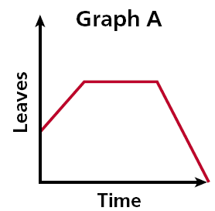
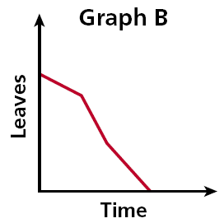
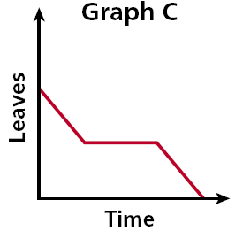

The air temperature increased steadily for several hours and then remained constant. At the end of the day, the temperature increased slightly before dropping sharply.

Key Words | Segment Description
The air temperature increased steadily
then remained constant
temperature increased slightly
dropping sharply

