GENERATING ORDERED PAIRS
y = x – 3  x y | 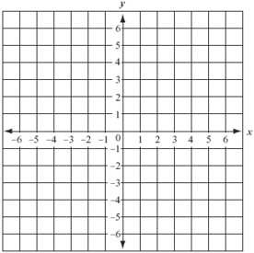
y = 2x – 4

x | y

y = -2x² + 2

x | y

y = 1

x | y

GENERATING ORDERED PAIRS
y = 2x² – 3

x | y

y = (2x)² – 4

x | y

y = -2x + 2

x | y

y = -1x

x | y

Example 1: For the function y = 10x + 5, find (2, y).

- For the function y = -3x -2 , find (-3, y).

- For the function y = 3x² + 1 , find (4, y).

Example 2: For the function y = 10x + 5, find (x, 35).

- For the function y = -3x -2 , find (x, 4).

- For the function y = 3x² + 1 , find (x, 13).

