Name ___________________________________________ December 4, 2014
CALCULATING EXPERIMENTAL PROBABILITY
Vocabulary: | Theoretical Probability  Experimental Probability-  Simple Event-  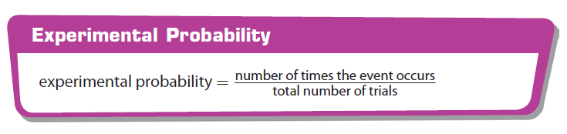  Example:  