[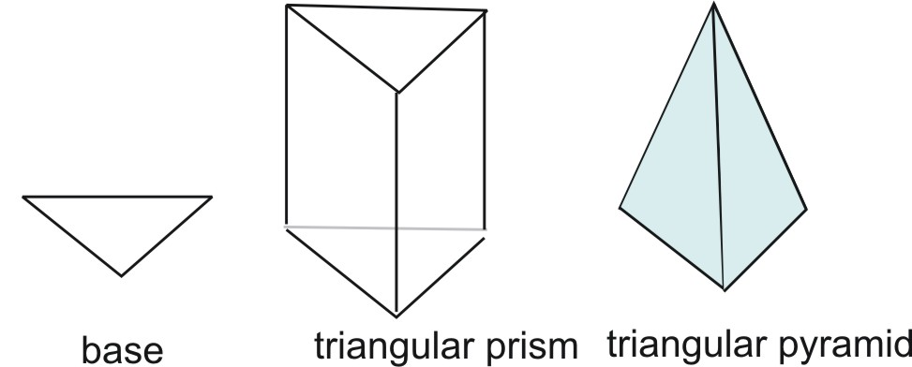](http://www.ck12.org/user:YWtlZWxlckBhY2VsZnJlc25vLm9yZw../section/Pyramids/)