5.1 Perpendicular and Angle Bisectors

equidistant -the same distance from two or more objects

locus -a set of points that satisfies a given condition

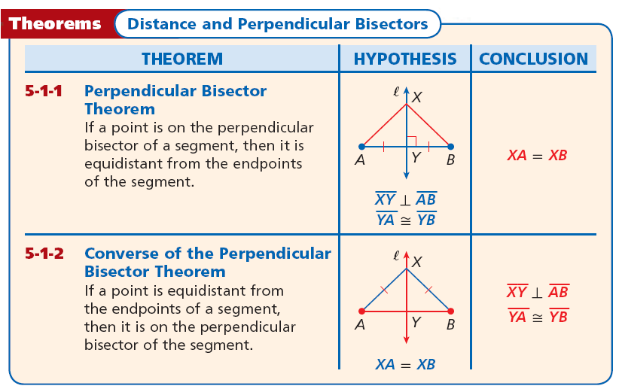

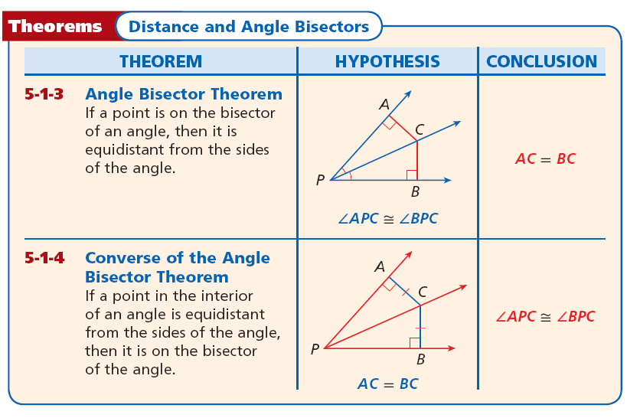

5.2 Bisectors of Triangles

concurrent -a point where three or more lines intersect at one point

point of concurrency -point where three or more lines coincide

circumcenter of a triangle -the point of concurrency of the three perpendicular bisectors of a triangle

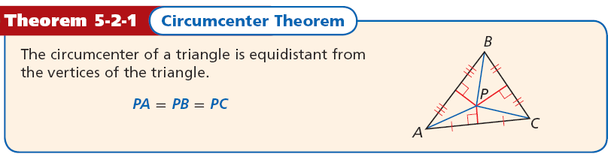

circumscribed circle -every vertex of the polygon lies on the circle

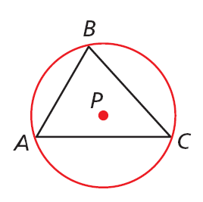

incenter of a triangle -the point of concurrency of the three angle bisectors of a triangle

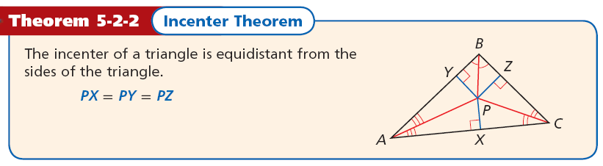

inscribed circle -a circle in which every side of the polygon is tangent to the circle

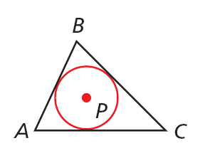

5.3 Medians and Altitudes of Triangles

median of a triangle -a segment whose endpoints are a vertex of a triangle and the midpoint of the opposite side

centroid of the triangle -the point of concurrency of the three medians of a triangle

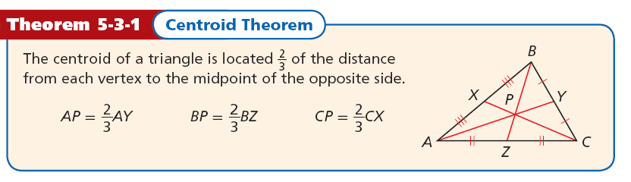

altitude of a triangle -a perpendicular segment from a vertex to the line containing the opposite side
orthocenter of a triangle -the point of concurrency of the three altitudes of a triangle

5.4 Triangle Midsegment Theorem

midsegment of a triangle -a segment that joins the midpoints of two sides of the triangle. Every triangle has three midsegments.

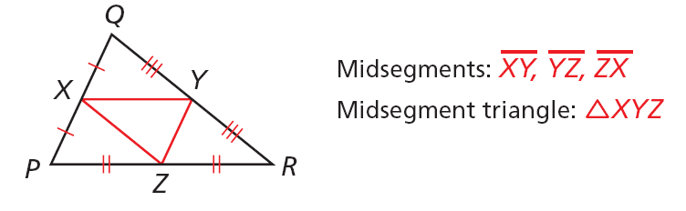

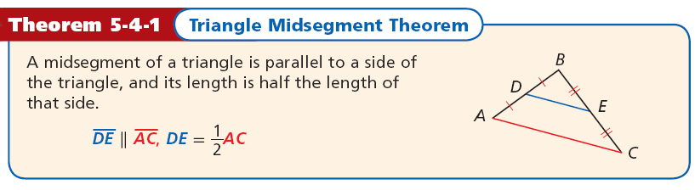

5.5 Indirect Proofs and Inequalities in One Triangle

indirect proof -a proof in which the statement to be proved is assumed to be false and a contradiction is shown

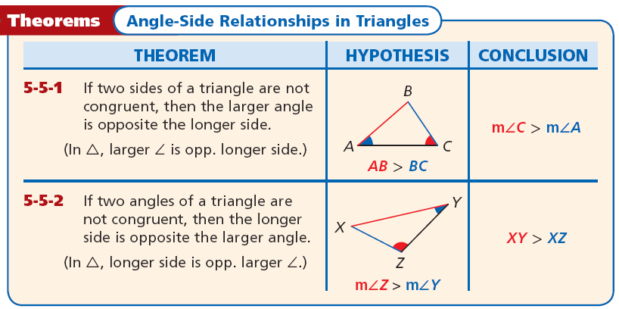

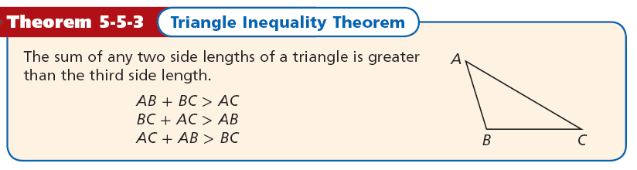

5.6 Inequalities in Two Triangles

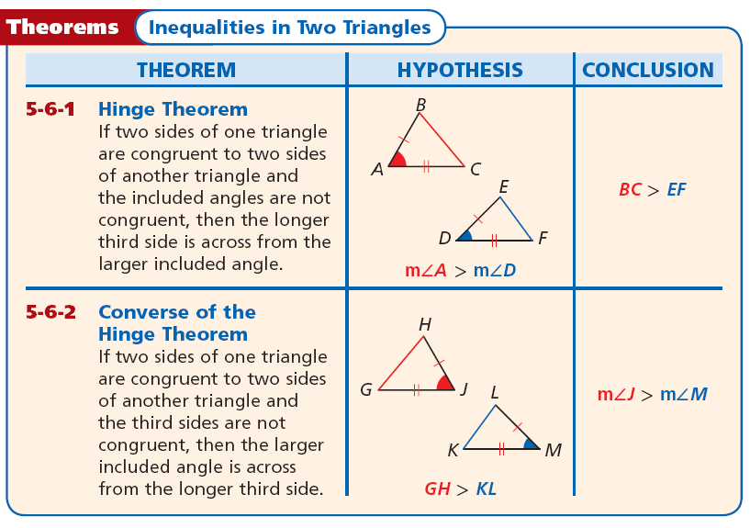

5.7 Pythagorean Theorem

Pythagorean triple -a set of three nonzero whole numbers a, b, and c such that a²+b²=c²

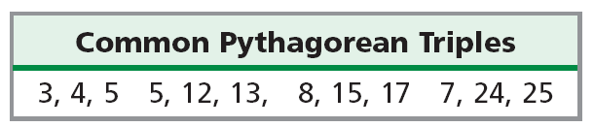

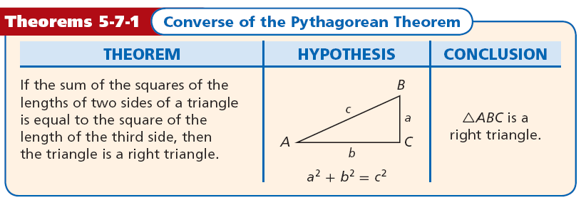

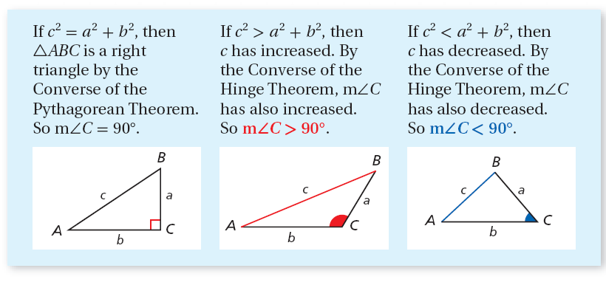

5.8 Applying Special Right Triangles

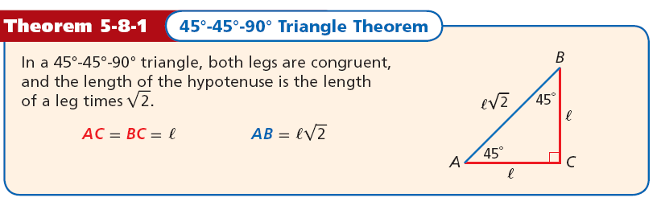

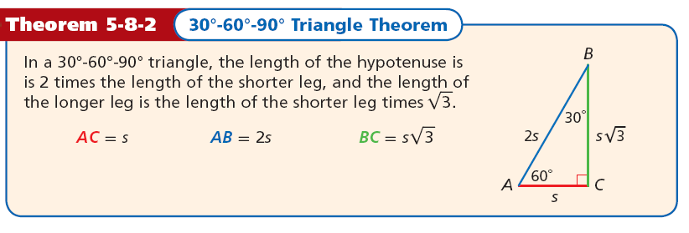

45°-45°-90° Triangle Theorem
In a 45°-45°-90° triangle, both legs are congruent and the length of the hypotenuse is the length of the legs times √2


30°-60°-90° Triangle Theorem
In a 30°-60°-90° triangle, the length of the hypotenuse is 2 times the length of the shorter leg, and the length of the longer leg is the length of the shorter leg times√3

