Name ___________________________________ December 10, 2014

CALCULATING EXPERIMENTAL PROBABILITY OF COMPOUND EVENTS
Vocabulary: | Compound Event-  Examples of a compound event:  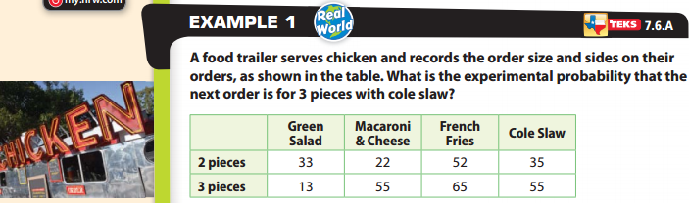  Step 1: Find the total number of trials, or orders.  Step 2: Find the number of orders that are for 3 pieces with cole slaw.  Step 3: Find the experimental probability.  P(3 pieces + coleslaw) _________________________________

